Practice Quiz MC Questions
- An economy is operating at a point inside its production possibilities curve ( PPC ). Which of the following will most likely cause the economy to move toward the current PPC in the short run?
- A decrease in government spending
- A decrease in inflation
- An increase in human capital
- An increase in employment
- An increase in imports
- An increase in which of the following will most likely promote economic growth?
- Taxes on investment
- The price level
- Human capital
- Consumption of nondurable goods
- Interest rates
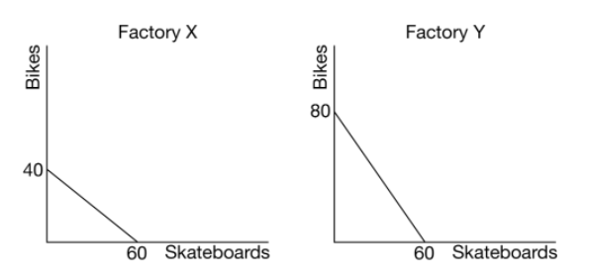
- The graph above shows the production possibilities curve for Factory X and Factory Y. If Factory X uses the same amount of resources to produce skateboards and bikes as Factory Y uses, which of the following is true?
- Factory X has an absolute advantage in producing bikes.
- Factory X has an absolute advantage in producing skateboards.
- Factory X has a comparative advantage in producing skateboards.
- Factory Y has a comparative advantage in producing skateboards.
- Factory Y has an absolute advantage in producing skateboards.
- Country X produces only apples and bananas. The following table shows prices and quantities of both products in two years.
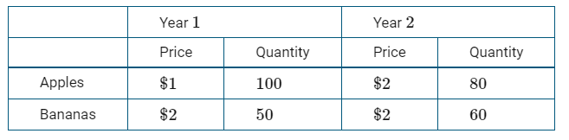
Assuming year 1 is the base year, what is the nominal and real gross domestic product (GDP) for year 2 ?
Nominal GDP Real GDP
- $200 $280
- $200 $200
- $280 $200
- $280 $560
- $560 $280
- Using 2010 as the base year, the gross domestic product (GDP) deflator in 2011 was 97. Which of the following must be true?
- The inflation rate in 2011 was positive.
- The inflation rate in 2011 was negative.
- The inflation rate in 2011 was zero.
- The purchasing power of a dollar decreased by 3 percent.
- The real output increased by 3 percent.
- A fiscal policy action to reduce inflationary pressure would be to increase which of the following?
- The required reserve ratio
- The discount rate
- Transfer payments
- Government spending
- Income tax rates
- If investment demand becomes less responsive to changes in interest rates, which of the following is true?
- An expansionary fiscal policy results in less crowding out.
- An expansionary fiscal policy results in more crowding out.
- An expansionary monetary policy is more effective.
- A contractionary monetary policy is more effective.
- An expansionary monetary policy results in more crowding out.
- The real interest rate will decrease.
- A contractionary monetary policy combined with an expansionary fiscal policy will
- decrease both income and consumption
- increase both income and consumption
- have uncertain effects on the interest rate and investment
- increase the interest rate and decrease investment
- increase both the interest rate and investment
- Which of the following transactions is included in the financial account of Country X’s balance of payments accounts?
- A firm in Country X sells robots to a firm in Country A.
- Country X sends financial aid to Country B.
- An individual in Country X receives dividend payments from a firm in Country C.
- An individual in Country X sends money monthly to family members in Country D.
- An individual in Country X buys new government bonds issued by Country E.
- Country X has a budget deficit. Which of the following changes in government budget outlays and tax revenues will result in a decrease in Country X’s government budget deficit?
Government Outlays Tax Revenues
Falls by $100 million Falls by $600 million
Falls by $200 million Falls by $200 million
Rise by $300 million Falls by $300 million
Rise by $400 million Rise by $600 million
Rise by $500 million Rise by $500 million
- The short-run Phillips curve implies there is a trade-off between
- rule making and discretionary policies
- monetary and fiscal policies
- inflation and unemployment
- budget deficits and interest rates
- interest rates and investment
- The measured unemployment rate is often criticized for understating the level of joblessness because
- individuals working in the underground economy are counted as employed
- individuals working more than one job are counted more than once
- discouraged workers are counted as unemployed
- discouraged workers are not counted in the labor force
- part-time workers are counted as unemployed
- An economy is in short-run equilibrium at a level of output that is greater than potential output. If there were no active fiscal or monetary policy intervention, which of the following changes in output and the price level would occur in the long run?
Output Price Level
- Increase Decrease
- Increase Increase
- Decrease Decrease
- Decrease Increase
- No change No change
- Country X’s government increases its spending without raising taxes. Which of the following is true about the effect on Country X’s real interest rates and its subsequent effect on Country X’s net exports?
- Real interest rates increase and net exports increase.
- Real interest rates increase and net exports decrease.
- Real interest rates increase with no change in net exports.
- Real interest rates decrease and net exports increase.
- Real interest rates decrease and net exports decrease.
- Assuming no government policies, which of the following will occur in the long run if the actual unemployment rate exceeds the natural rate of unemployment?
- Prices will increase.
- Unemployment will increase.
- Wages will fall.
- Aggregate demand will increase.
- Long-run aggregate supply will decrease.
- If the central bank of a country wishes to maintain a stable nominal interest rate after a decrease in consumers’ spending, taking which of the following actions will achieve the goal?
- Increasing government spending
- Increasing income tax rates
- Decreasing the required reserve ratio
- Decreasing the discount rate
- Selling government bonds
- Which of the following will most likely cause a depreciation in a country’s currency?
- An increase in the country’s price level
- An increase in the country’s real interest rate
- A decrease in the country’s expected inflation
- A decrease in the country’s real gross domestic product
- A decrease in the country’s money supply
- Suppose that a country’s nominal gross domestic product (GDP) was $1,000 in year 1 and $2,000 in year 2. If year 1 is the base year and real GDP in year 2 was $1,000, which of the following is true?
(A) Prices fell by 50% between year 1 and year 2.
(B) Prices doubled between year 1 and year 2.
(C) Prices remained the same between year 1 and
year 2.
(D) More goods and services were produced in
year 2 than in year 1.
(E) Fewer goods and services were produced in
year 2 than in year 1.
- A country’s economy is currently in equilibrium at point R. Which of the following policy actions could the country’s government take to achieve potential output (YP) ? 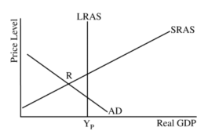
(A) Decreasing the money supply
(B) Decreasing investment tax credits
(C) Increasing interest rates
(D) Lowering the administered interest rates
(E) Increasing the minimum wage
- An increase in the number of which of the following will lead to an increase in the unemployment rate?
(A) Discouraged workers
(B) Business start-ups
(C) Self-employed persons
(D) Persons working 30 instead of 40 hours per week
(E) Persons quitting part-time jobs to look for full-time ones
- Banks expand the money supply when
(A) issuing credit cards
(B) printing money
(C) cashing checks
(D) making loans
(E) accepting deposits
- If the government implements an expansionary fiscal policy, how will real gross domestic product (GDP) and the price level be affected in the short run?
Real GDP Price Level
(A) Increase Decrease
(B) Decrease No change
(C) No change Increase
(D) Increase Increase
(E) Decrease Decrease
- The graph above shows the production possibilities curves (PPC) for an economy. The concept of opportunity cost is best represented by which of the following? 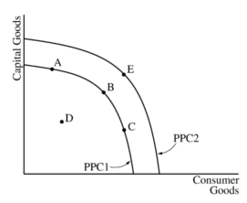
(A) A shift from PPC1 to PPC2
(B) A movement from point A to point D
(C) A movement from point B to point C
(D) A movement from point C to point E
(E) A movement from point D to point B
- Which of the following is most likely included in gross domestic product?
(A) Matt gives his secondhand bicycle to his brother.
(B) Sal paints his own bicycle.
(C) Jake buys a new bicycle.
(D) Mike buys a share of stock in a bicycle firm.
(E) Daniel bikes to school every day.
- Increased spending on which of the following contributes most to long-term economic growth?
(A) Social security and other transfer payments
(B) New automobiles and homes
(C) Education and infrastructure
(D) Imported consumer goods
(E) Interest payments on national debt
- If consumers in Canada increase their demand for products that are manufactured in India, which of the following will occur?
(A) The Indian rupee will depreciate.
(B) The Canadian dollar will appreciate.
(C) India’s financial capital inflow will increase.
(D) Canada’s financial capital inflow will increase.
(E) The supply of Canadian dollars will decrease.
- A bank has $200 million in demand deposits and $150 million in reserves. The reserve ratio is 20 percent. What is the maximum amount of loans the bank can make from its reserves?
(A) $750 million
(B) $150 million
(C) $110 million
(D) $50 million
(E) $40 million
- An increase in the expected inflation rate will cause the
(A) short-run Phillips curve to shift to the left
(B) short-run Phillips curve to shift to the right
(C) long-run Phillips curve to shift to the left
(D) long-run Phillips curve to shift to the right
(E) actual inflation rate to fall below the expected inflation rate
- If government spending increases and at the same time a country's central bank sells bonds in the open market, the interest rate and private investment in plant and equipment (P&E)will most likely change in which of the following ways?
 | Interest Rate | Private Investment in P&E
A | Increase | Increase
B | Increase | Decrease
C | Increase | No change
D | No Change | Decrease
E | Decrease | Decrease
- If the consumer price index increases from 200 to240 in a one-year period, then the inflation rate is
(4) 16.67 percent
(B) 20 percent
(C) 25 percent
(D) 40 percent
(E) 140 percent
- A nation's unemployment rate is the ratio of the number of unemployed seeking employment to the nation's
(AV labor force
(B) potential gross domestic product
(C) number of employed
(D) working-age population
(E) total population
- The demand curve for money shifts to the right when
(A) the nominal interest rate decreases
(B) the nominal gross domestic product increases
(C) the real gross domestic product decreases
(D) inflation decreases
(E) the velocity of money increases
- An increase in both the inflation rate and the unemployment rate can be illustrated by
(A) a movement along the short-run Phillip curve
(B) a rightward shift of the short-run Phillip curve
(C) a leftward shift of the short-run Phillips curve
(D) a rightward shift of the aggregate demand curve
(E) a leftward shift of the aggregate demand curve
- Assume Country X has the following international transactions, in billions of dollars, during a given period of time.
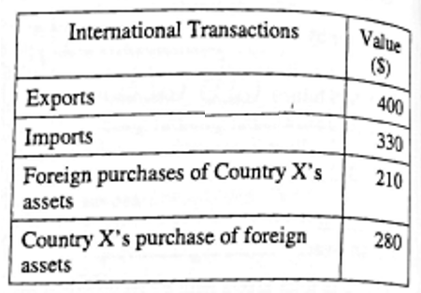
What is the balance on the current account,
in billions of dollars, for the period?
(A) -140
(B) -70
C) -O
D) +70
(E) +140
- If the required reserve ratio is 10 percent, what is the maximum change in the money supply from the central bank buying $50,000 worth of bonds?
(A) $5,000
B $45,000
C) $55.000
(D) $450,000
(E) $500,000

